**Question for discussion boards**

1. I cannot make a CONST variable show in the properties of the class.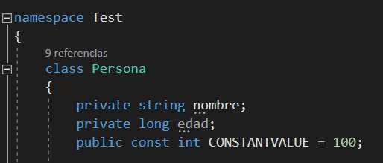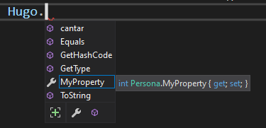

As soon as I get rid of the “const” modifier it shows in the properties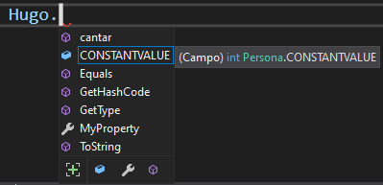

Is it a rule that constant values are hidden in classes?